HOLCOMBE PARISH COUNCIL
IN THE COUNTY OF SOMERSET

Email: clerk@holcombesomerset-pc.gov.uk

Application for Interment at Holcombe Cemetery

Name and address of applicant: Full name and address of deceased:



Type of plot:
Exclusive use of required:
lnterment in previous plot:
Grave I Cremation
Yes I No
Yes/ No
Age of deceased:

Date of death:
Nominations for subsequent interments in same plot:

Please indicate below application requirements and total fee enclosed:

Interments:

Exclusive use:

Memorials: Interment of ashes:

Memorial without remains:
Single
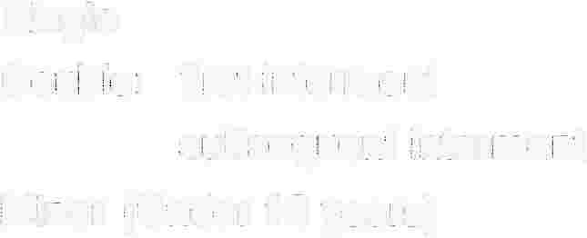Double: first interment subsequent interment
Minor (Under 16 years)

Grave plot
Cremation plot
Transfer of exclusive use deed

Headstone and inscription
Changes to inscription

Interment
Memorial tablet
Memorial tablet and vase

In cremation plot

Total paid:
£138.00
£182.00
£146.00
No Charge

£197.00
£41.00
£31.00

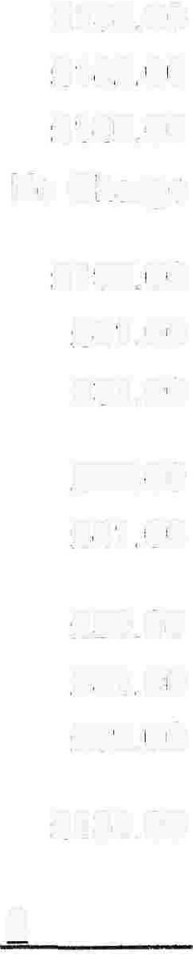£77.00
£41.00

£59.00
£31.00
£59.00

£131.00

Name and address of person who can authorise subsequent interments: (e.g. younger generation family member, family solicitor)

Name and address to contact about the grave upkeep, if different from applicant:

ACKNOWLEDGMENT OF APPLICATION FOR INTERMENT To:

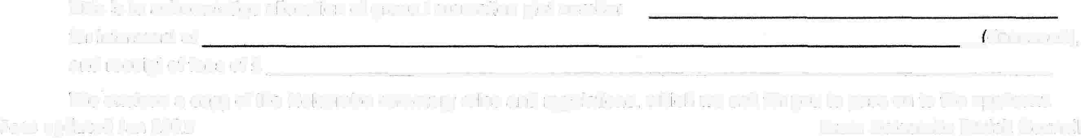This is to acknowledge allocation of grave I cremation plot number for interment of

(deceased),
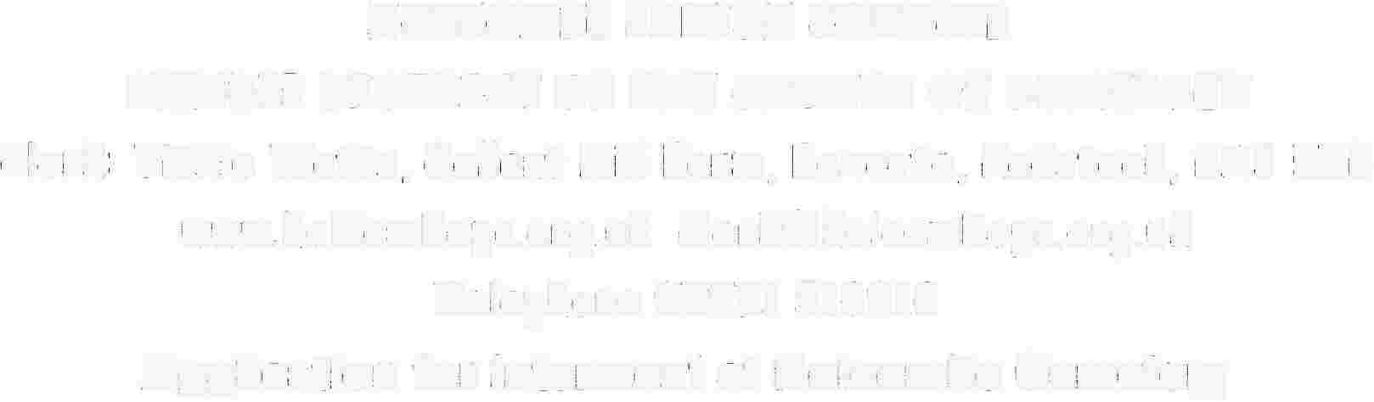and receipt of fees of £-----------------------------
Please note the cemetery rules and regulations are available on the website www.holcombesomerset-pc.gov.uk

Fees updated Jan 2023 From Holcombe Parish Council

