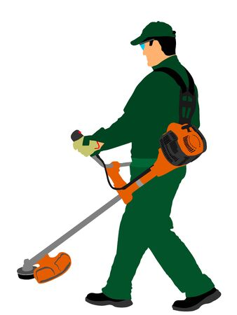
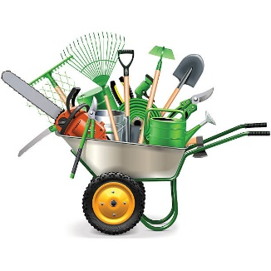
Community Clean Up & Litter Pick

Come and spend a couple of hours helping to spruce up our village
All ages welcome!

There are weeds to pull, brambles to cut, litter to pick & hedges to trim

Please bring your own tools; litter pickers, hi-viz vests & bin bags to be provided

Saturday 28 March

Meet at the Village Hall at 10am
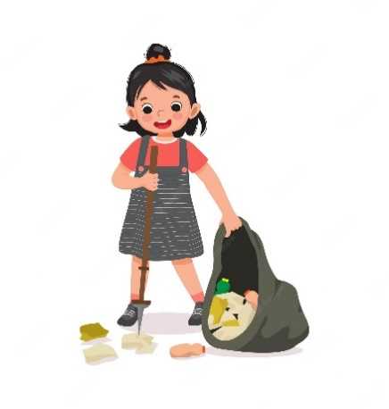
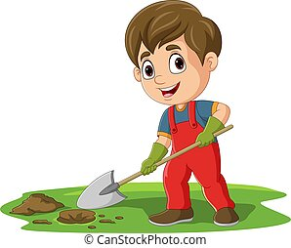
Refreshments on completion

(Courtesy of The Pudding Kitchen)

